## IIR filter Design

**Block A: Second order Notch filter**

Central frequency $ω_{w}= 2π*\frac{4915}{fs}=0.3π$

Filter parameters

$$β=\cos\left(ω_{w}\right)=0.58778$$

$$bandwidth=\cos^{-1}\left(\frac{2α}{1+α^{2}}\right)$$

By trial and error in Matlab, we found that when the bandwidth = 0.015 $π$, the gain of the filter and the distortion of the filter is the most suitable for our application, further analysis will be done in the later part of this report about this.

Therefore $α=\frac{1}{cos⁡(bandwidth)}- \sqrt{\frac{1}{{\cos\left(bandwidth\right)}^{2}-1}}= 0.9540$.

The notch filter has transfer function of

$$H_{A}\left(z\right)=\frac{1+α}{2}*\frac{1-2βz^{-1}+z^{-2}}{1-β*\left(1+α\right)z^{-1}+αz^{-2}}$$

The magnitude and phase response of the filter has been plotted below

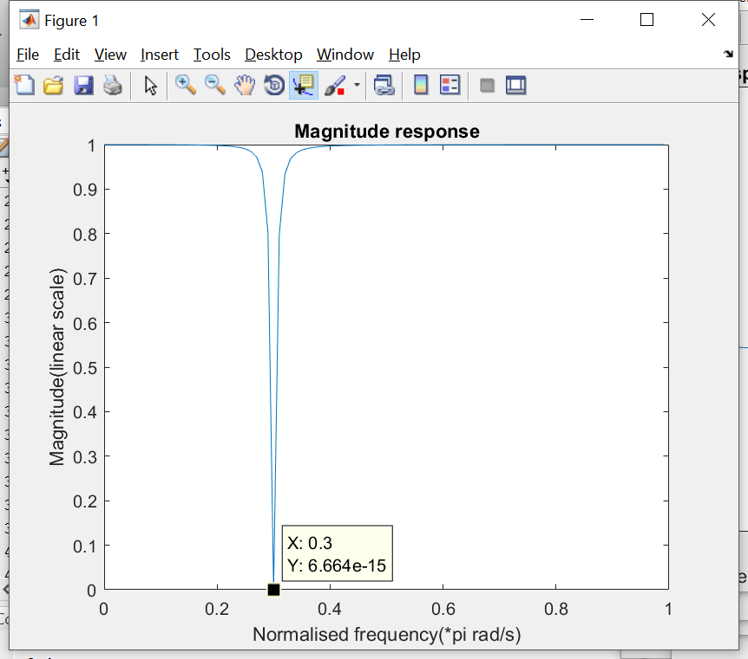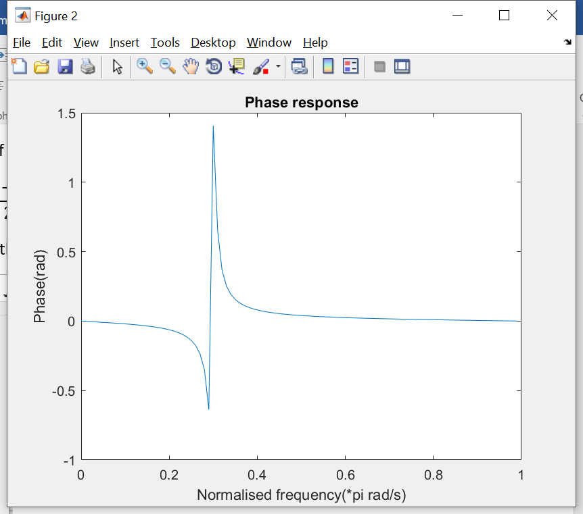

As the magnitude response shows, the gain of the filter at $ω_{w}$ is 20log(6.664e-15) = -283.52dB << -60dB, therefore this filter will size up the design requirement.

The phase response of the block A filter is not linear, which is different from FIR filters.

**Block D: LPF**

Passband: [0, 4096]

Stopband: (4096, inf)

Passband ripple: <4E-4

Stopband ripple: 0.001

Ripple and filter type analysis

Ripple in passband, cascading with Block A: <0.01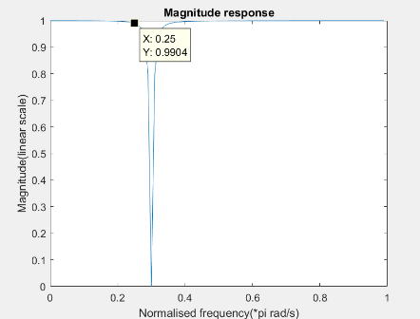

It was known from the magnitude response of the filter A that it will introduce a ripple at the passband edge ( $2π*\frac{4096}{fs}$ = 0.25 $π$) of filter D, and the ripple has been estimated to be 1-0.9904 = 9.6E-3. Therefore, $1-\left|H_{A}\left(Z\right)\right|*\left|H_{D}\left(Z\right)\right|=1-\left(0.9904\right)*{(1-rp}_{D})<0.01$, rp_D<0.000403877, rp_D = 4E-4 was set to satisfy this condition. So, it’s preferably to have a flat passband from the low pass filter in this case. Therefore, a **Chebyshev Type 2 filter** has been implemented.

The frequency and phase response of the filter has been plotted in the diagram below

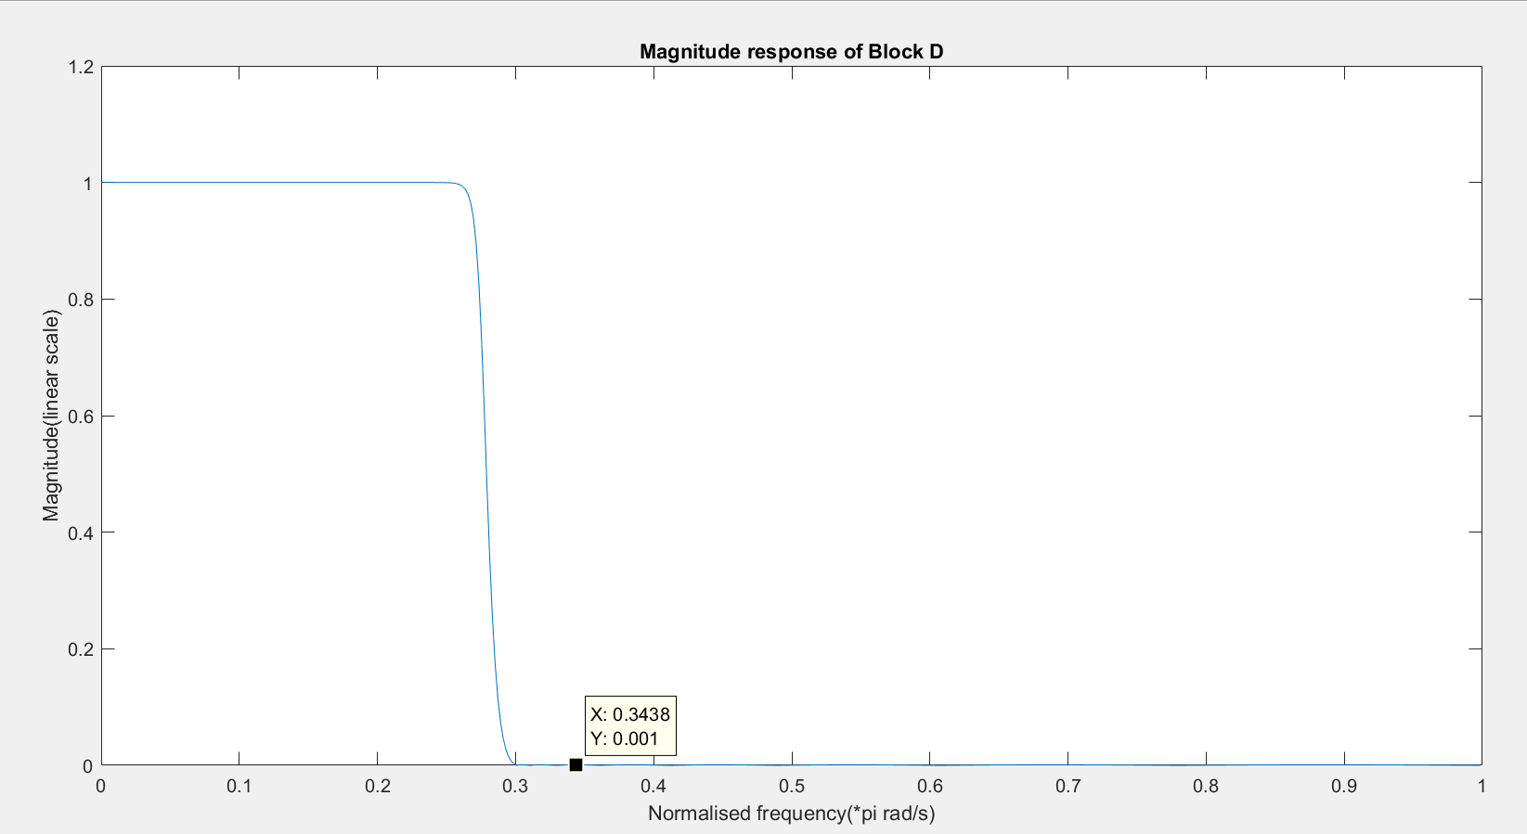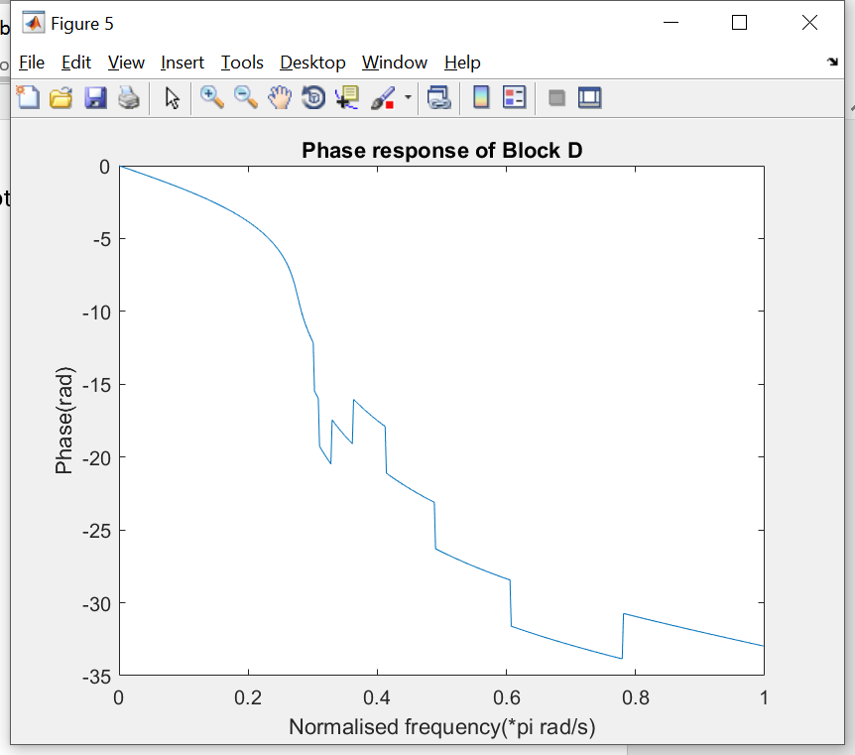

As the magnitude plot shows, the filter has a flat passband and stopband with ripple of 0.001, as we designed.

By cascading A and D together, we have phase and magnitude response as shown below

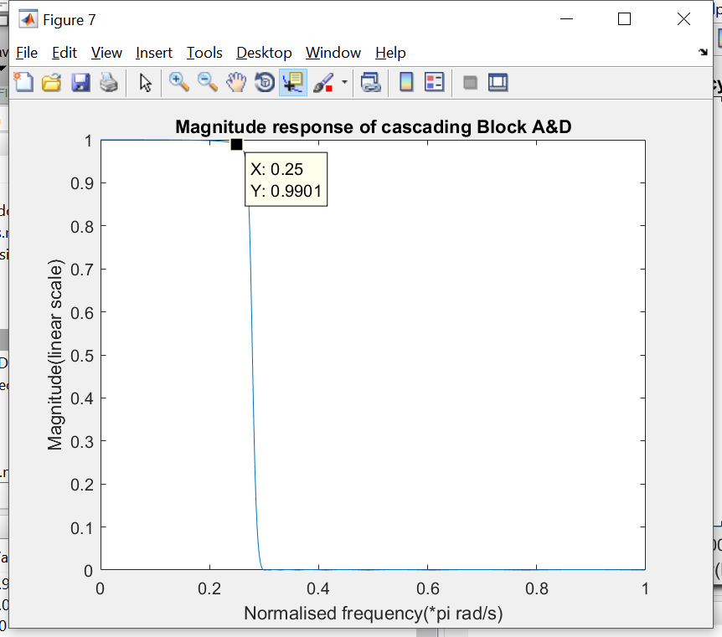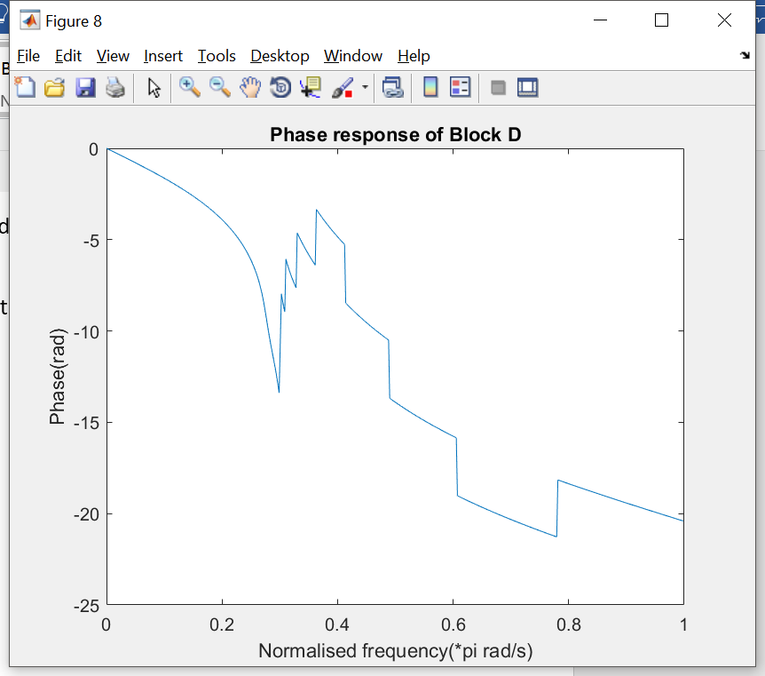

As analysed before, the passband ripple of filter A+D is 1-0.9901 = 9.9E-3 < 1%, therefore, the design of A and D satisfy the requirements.

**Block B: HPF**

Passband: [8192, inf ), because the modulated signal has been shifted and centred at fc = 12288Hz, and the lower bound of this signal is 12288-bandwidth = 12288-4096 = 8192.

Stopband: [0, 8192)

Passband ripple: 4.5E-3

Stopband ripple: 0.001

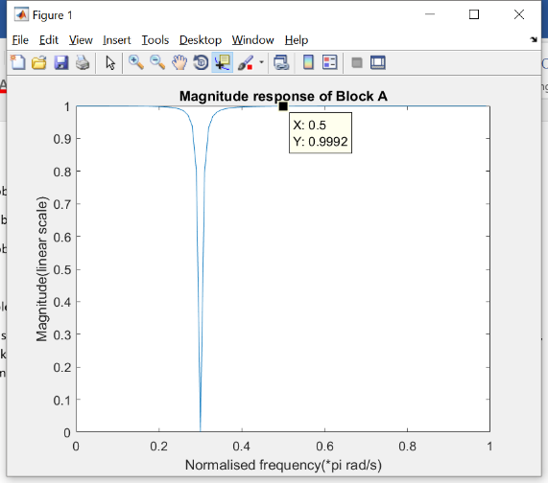

Ripple and filter type analysis

It has been required that cascading A B and C should have ripple less than 2% of the original signal, and knowing that the gain of block A at the passband edge of block B, f = 8192, i.e, 0.5 $π$ at normalised angular velocity, is 0.9992. Therefore, the ripple allowance for cascading B and C will be calculated as below.

$$1-\left|H_{A}\left(Z\right)\right|*\left|H_{B}\left(Z\right)\right|*\left|H_{C}\left(Z\right)\right|=1-\left(0.9992\right)*{(1-rp}_{B})*{(1-rp}_{C})<0.01$$

For the convenience of calculation, we set ${rp}_{B}= {rp}_{C}$, therefore, ${rp}_{B}= {rp}_{C}<4.61E-3$

Therefore, the passband ripple for Block B is 4.5E-3. Since a flat response in the passband is always the best option to minimise the ripple, therefore we still choose **Chebyshev Type 2 filter** to implement Block B.

The magnitude and phase response of the filter has been plotted as below.

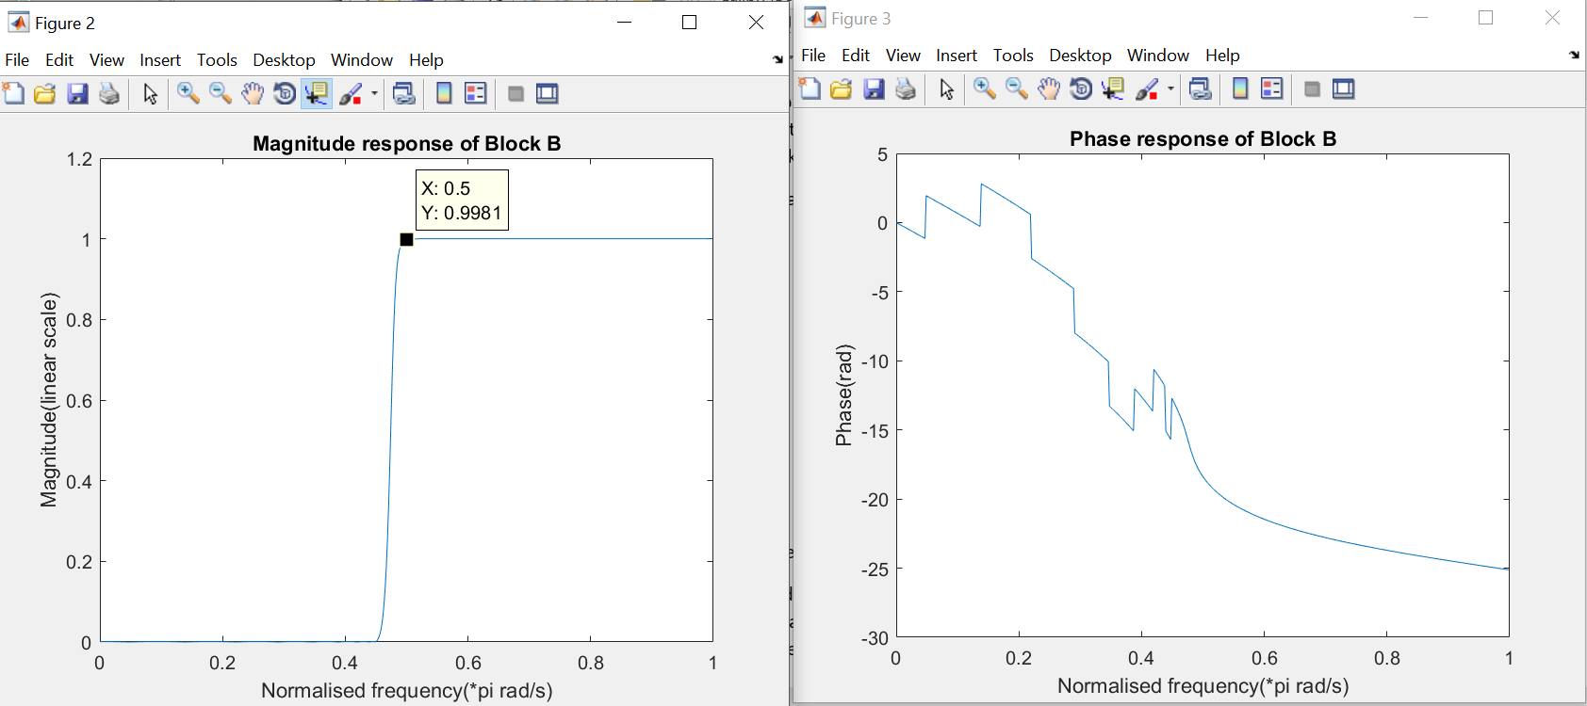

As expected, the stopband has ripple of 0.001 and the magnitude response for the passband is flat.

Further analysis on designing Block C

As the magnitude response show, the ripple for this filter at 0.5pi (passband edge) has gain of 0.9939, that means the ripple 1 - 0.9981 = 1.9E-3, recall the magnitude at the 0.5pi for block A is 0.9992, This means the ripple allowance for cascading block C is 1-0.9992*0.9981*(1-rp_C)<0.01.

Rp_C<0.00732128 = 7.32E-3. This is a sanity check for the result of Rp_C<4.61E-3, it means that the performance of block B is better than expected.

Continue with the verification of block B, the signal after Block B HPF is shown below as

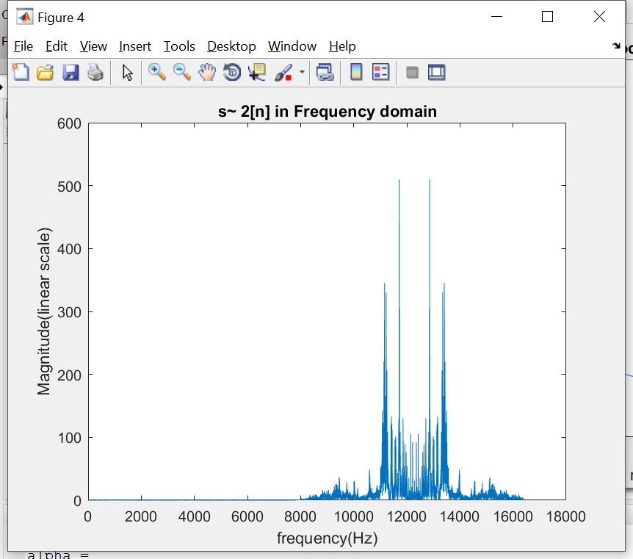

This is the modulated signal bandpass signal.

Using the same demodulation method, we have the signal as below show

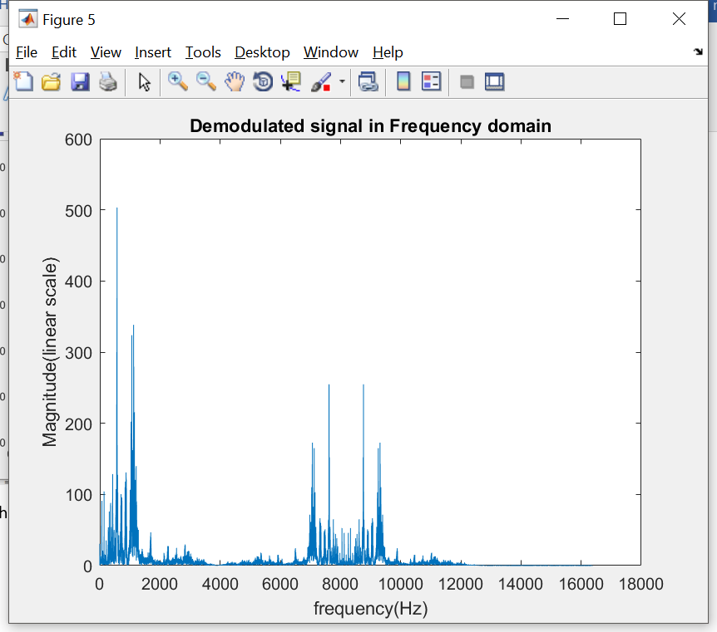

**Block C: LPF**

Passband: [0, 4096),

Stopband: (4096, inf)

Passband ripple: 4.5E-3, as discussed previously

Stopband ripple: 0.001

As the diagram below is the magnitude and phase response of the block C lowpass filter

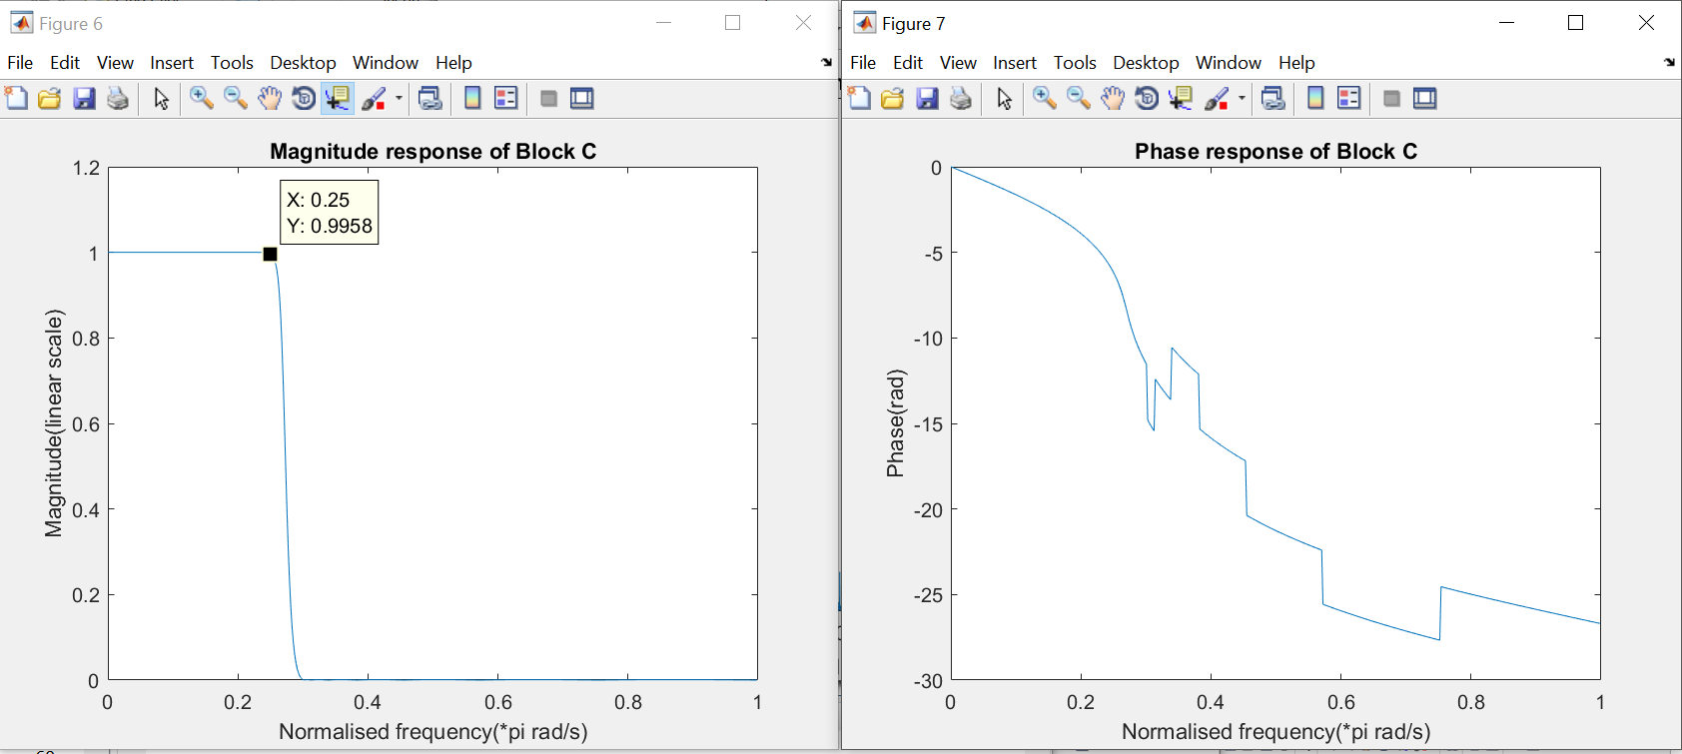

As expected,

Signal s2[n] after Block C,

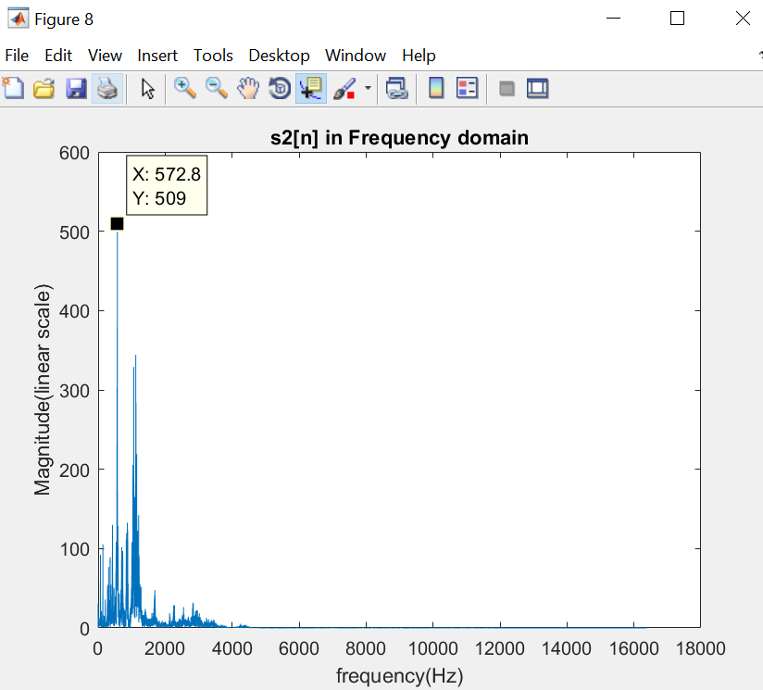

The phase offset has been set to +pi/3 to obtain the original magnitude, by test and error.

2b. Minimise the filter orders

Its known that Elliptic filter has the narrowest transition band as well as the lowest required order among different type of filters.

Therefore, we replace the Chebyshev type 2 filters in block B, C and D to complete this task.

Recall the design requirement for Block B, C and D are shown below

|  |  |  |  |
| --- | --- | --- | --- |
|  | **Block B** | **Block C** | **Block D** |
| **Passband** | [8192, inf) | [0, 4096), | [0, 4096] |
| **Stopband** | [0, 8192) | (4096, inf) | (4096, inf) |
| **Passband ripple** | 4.5E-3 | 4.5E-3 | <4E-4 |
| **Stopband ripple** | 0.001 | 0.001 | 0.001 |
| **Filter Type** | Chebyshev Type 2 | Chebyshev Type 2 | Chebyshev Type 2 |
| **Minimum Order** | 18 | 15 | 17 |

Optimised order design

|  |  |  |  |
| --- | --- | --- | --- |
|  | **Block B** | **Block C** | **Block D** |
| **Filter Type** | Elliptic | Elliptic | Elliptic |
| **Minimum Order** | 9 | 8 | 9 |

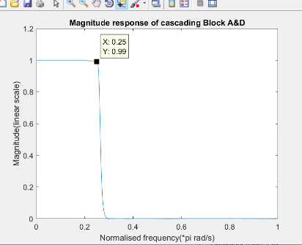Requirement check

1. The filters are implemented to have minimum order
2. Cascading Block A and D has ripple of 1-0.99 = 0.1 at 0.25pi(the edge of passband)
3. The ripple of Block B has been estimated to be (1-0.9955), and that in C is (1-0.9955), therefore the total ripple of cascading A B and C is $1-\left|H_{A}\left(Z\right)\right|*\left|H_{B}\left(Z\right)\right|*\left|H_{C}\left(Z\right)\right|=1-0.9992*{0.9955}^{2}=$

Block B magnitude and phase response

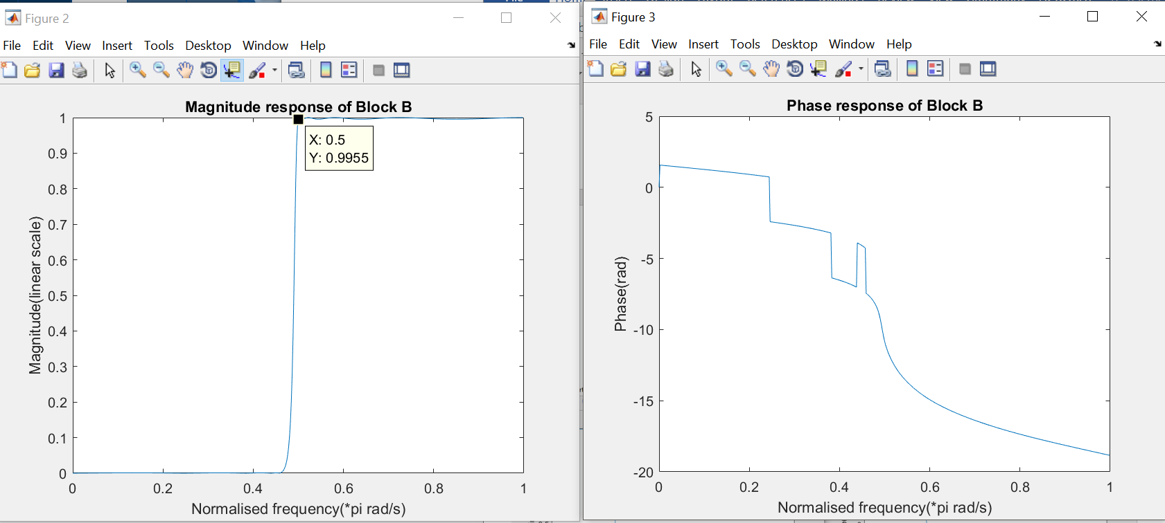

Block C magnitude and phase response

